Healthy Eating


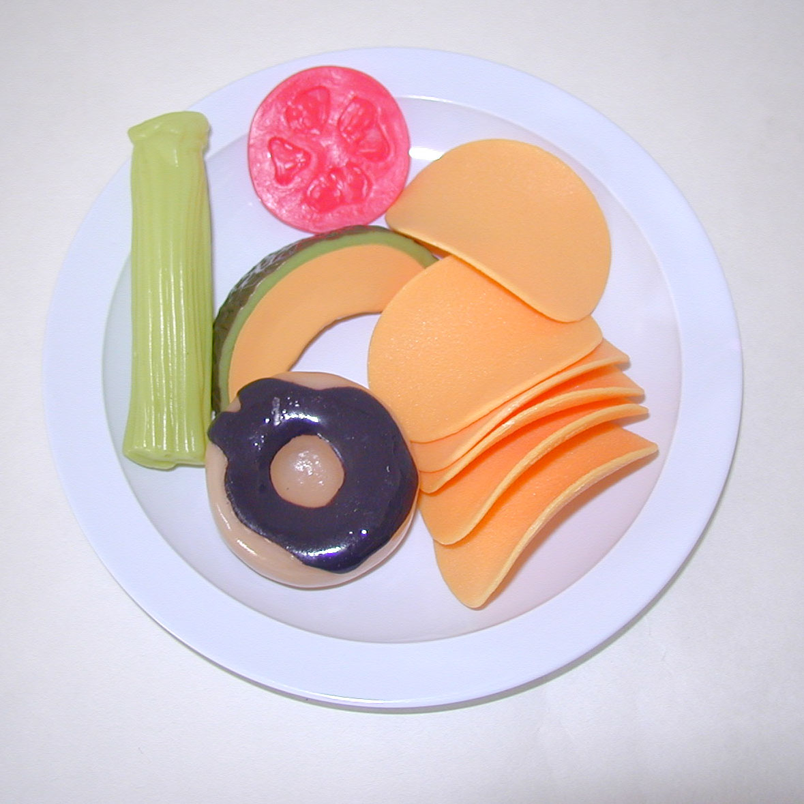

Teachers’ Notes

It should only take about 10 minutes to read these notes. They give some details about the kit.

Additional information is given at the end for interest and further research.

PLEASE READ THIS

Disclaimer

The Teacher Scientist Network (TSN) is pleased to lend its kits to schools, and believes each kit to be suitable for its suggested use. However, we recommend that teachers thoroughly examine and check each kit to make sure it is fit for the purpose intended, making any risk assessment that is appropriate.
The TSN excludes any liability for injury or damage howsoever caused by the use of the kits, is not responsible for the standard of development or safety of any of the products used in the kits, and makes no warranty against errors and omissions in any kit or accompanying material.

Use of Kits

The Teacher Scientist Network is pleased to lend this kit to your school free of charge, and hope that you find it useful.

Please:

- Read the disclaimer and any teachers’ notes.
- Check the kit against the contents list before you take it away.
- Return the kit in a complete and tidy condition ready for the next school
- Don’t keep the kit beyond the date agreed for its return.
- Take care of the equipment.

Although we try to make the kits as robust and child-proof as possible, we might ask you to pay for, or to contribute towards, any breakages or losses other than normal wear and tear.

Thank you for looking after the kit.

Contents

Page
Disclaimer 3
Contents of kit 5
Introduction 6
Additional background information 7
Appendix 1 8
Complete food list for Healthy Eating 1
Appendix 2 10
Complete food list for Healthy Eating 2

Contents of kit

1 large selection of foods
10 plates

1 “Join the Activators” CD-ROM

3 posters:
- fruit
- vegetable
- food guide pyramid

1 set teachers’ notes containing full list of foods in appendices

Introduction

The kit can be used in many ways.

Some ideas are:
- write down what everyone has eaten in the past 24 hours. How did their diet compare with the 5-a-day pyramid?
- Look at the different food groups and how they make up a healthy diet
- Plan a healthy meal for a family
- Plan a day’s worth of meals and include 5 servings of fruit + vegetables
- Look at food labels to see how much sugar/fat/salt is in different foods
- Find out how much energy is given by different foods
- Identify examples of food as fruit or vegetables (tomatoes are fruits!)
- Compare animal and human diets. Why are they different?
- Find out how much different foods cost to buy. Why are some more expensive than others?
- Crush some bran flakes and use a magnet covered in clingfilm to stir the powdered cereal for about 10 minutes. When any excess bran flakes are washed off little pieces of metal can be seen. These are the added iron in the bran flakes – they really do use iron filings!

The Activators CD-ROM also has worksheets and ideas that can be printed out and used in class.

Red arteries

White lymph vessels

Blue veins

Foetus – fits in uterus
Additional Background Information

Useful websites:

www.food.gov.uk/interactivetools/educational/bashstreetdiet/
Gives advice and ideas on how to get 5 portions a day in a fun and accessible way.

www.foodfitness.org.uk
This is the government website promoting healthy eating in primary schools.

www.dh.gov.uk/PolicyAndGuidance/HealthAndSocialCareTopics/FiveADay/fs/en
Gives information in a more formal way.

www.foodlink.org.uk
This promotes “A-Z programme for safety throughout the food chain” and shows how food can spread germs if not treated correctly.

Appendix 1

Food Contents Box 1

Type of Container | Number of pieces | Food
bag | 10 | bananas
bag | 10 | black grapes
bag | 10 | lemons
bag | 10 | red apples
bag | 10 | pears
bag | 10 | cucumber slices
bag | 10 | asparagus
bag | 10 | tomato slices
bag | 10 | lettuce
bag | 10 | broccoli
bag | 10 | sweetcorn
bag | 10 | peas
bag | 10 | green peppers
bag | 30 | chips
bag | 10 | meat slice
bag | 10 | bacon slice
bag | 10 | cheese slices
bag | 10 | fried eggs
bag | 10 | hot dog sausages + rolls
bag | 10 | boiled eggs
bag | 10 | scones
bag | 10 | pink iced buns
bag | 10 | chocolate biscuits
bag | 10 | jam tarts
bag | 10 | croissant
bag | 10 | pizza
bag | 10 | sliced white bread
bag | 10 | red ice cream cones
bag | 10 | rich tea biscuits
bag | 10 | blackcurrant jam
bag | 10 | tomato ketchup
bag | 10 | salad cream
bag | 10 | tuna
bag | 10 | baked beans
bag | 10 | macaroni cheese
bag | 10 | mince + onion
bag | 10 | peach slicess
bag | 10 | plum tomatoes
bag | 10 | processed peas
box | 10 | apple + blackberry pie
box | 10 | soup in a cup
box | 10 | breakfast wheat biscuits
box | 10 | orange lollies
box | 10 | cream crackers
box | 10 | tea
bag | 10 | cat food

Appendix 2

Food Contents Box 2

Type of Container | Number of pieces | Food
bag | 10 | orange segments
bag | 10 | strawberries
bag | 10 | pineapple slices
bag | 10 | melon
bag | 10 | oranges
bag | 10 | green grapes
bag | 10 | celery
bag | 10 | tomato slices
bag | 10 | lettuce
bag | 10 | sugarsnap peas/mangetout
bag | 10 | aubergine
bag | 10 | tomatoes
bag | 10 | cauliflower
bag | 10 | red pepper
bag | 10 | onions
bag | 20 | crisps
bag | 10 | frankfurters
bag | 10 | pasta + meatballs
bag | 10 | beefburgers + rolls
bag | 10 | chicken leg
bag | 10 | scrambled eggs
bag | 10 | poached eggs
bag | 10 | cheese slices
bag | 10 | croissant
bag | 10 | sliced French bread
bag | 10 | pretzel
bag | 10 | shortcake biscuits
bag | 10 | chocolate iced buns
bag | 10 | digestive biscuits
bag | 10 | yellow ice cream cones
bag | 10 | raspberry flans
bag | 10 | strawberry jam
bag | 10 | brown sauce
bag | 10 | tomato sauce
bag | 10 | mince + onion
bag | 10 | ravioli
bag | 10 | chicken curry
bag | 10 | fruit cocktail
bag | 10 | rhubarb
bag | 10 | mushy peas
bag | 10 | sweetcorn
bag | 10 | potatoes
bag | 10 | tomato soup
box | 10 | apple juice
box | 10 | pizza
box | 10 | cupcakes
box | 10 | wafer biscuits
bag | 10 | dog food

